SOLAR POWER SYSTEMS (OFF GRID SOLAR SYSTEMS):

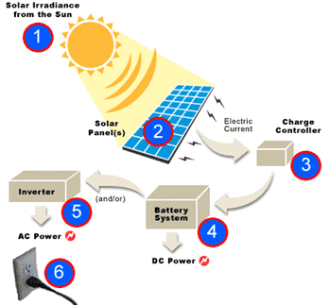
Solar Power systems are sometimes used as "off the grid" (not utalising a power utility like Escom) systems. They reduce your utility bill (if not using utilities) while still giving you the electricity you need to run your eg house, business, farm or factory (AFTER BEING THE MOST ENERGY EFFICIENT AS POSSIBLE). They are ideal for locations where grid power is e.g. not available, where it is expensive to get/operate or where a client wants to get off the grid for environmental and/or cost saving reasons etc. Where grid power is available, the client can stay on the grid and use it as a backup if needed, but using solar energy as their main source of power. This is beneficial during prolonged period of rain or periods when more power is utilised than the solar system can produce. In this case you will still get a Escom/ power company bill, but it will be greatly reduced.

A solar power system typically consists of solar panels that convert solar rays into electric current (DC - Direct Current), this current is send to a charge/MPPT controller that manages the charging rate and output voltage of the current flowing to the battery bank. From the battery bank the power flows to an inverter that converts the 12/24/48 Volt DC (Direct Current) power to 220/230 Volt AC (Alternating Current) that you can use in your home, farm, business or office.
As can be seen this is a complex system and requires indepth solar, electrical and technical engineering /inter related along with eg extensive product knowledge to design as well as etc.

Scientifically patented calculations apply to the various systems to eg aid preplanning, which can be discussed in consultation (which is an element of training to use systems, especially offgridding; Applied to eg energy saving lifestyle transformations counselling etc to eg use especially these types of systems).

(Please note E.G. calculators (patented & scientifically proofed) ETC to establish a quotation applied to this system/s are normally for sale).

